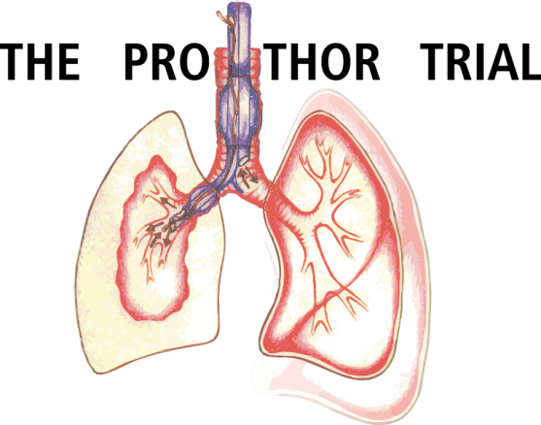

Protective Ventilation with Higher versus Lower PEEP during one-lung ventilation for thoracic surgery
Ver 1.8

APPENDIX
DEFINITIONS AND SCORES

DEFINITIONS and SCORES

NPPV | Noninvasive Positive-Pressure Ventilation
CPAP | Continuous Positive Airway Pressure
NIV | Noninvasive ventilation
BUN | Blood urea nitrogen
ALT | alanine aminotransferase, serum glutamic-pyruvic transaminase (SGPT)
AST | aspartate aminotransferase, serum glutamic-oxaloacetic transaminase (SGOT)
Hb | Hemoglobin
WBC | White blood cell count
PTT | Partial Thromboplatin time
INR | International normalized ratio
PT | Prothombin time (acc. To “Quick”)

CCS Score : Canadian Cardiovascular Society Grading System score for describing and categorising effort-related angina pectoris.

Class I
Angina with strenuous, rapid, or prolonged exertion (Ordinary physical activity such as climbing stairs does not provoke angina.)
Class II
Slight limitation of ordinary activity (Angina occurs with postprandial, uphill, or rapid walking; when walking more than 2 blocks of level ground or climbing more than one flight of stairs; during emotional stress; or in the early hours after awakening)
Class III
Symptoms with everyday living activities, ie. moderate limitation. Marked limitation of ordinary activity (Angina occurs with walking 1-2 blocks or climbing a flight of stairs at a normal pace.)
Class IV
Inability to perform any activity without angina or angina at rest, ie. severe limitation

NYHA Score : New York Heart Association Functional Classification

Class I:
Cardiac disease, but no symptoms and no limitation in ordinary physical activity, e.g. no shortness of breath when walking, climbing stairs etc.
Class II:
Mild symptoms (mild shortness of breath and/or angina) and slight limitation during ordinary activity.
Class III:
Marked limitation in activity due to symptoms, even during less-than-ordinary activity, e.g. walking short distances (20–100 m). Comfortable only at rest.
Class IV:
Severe limitations. Experiences symptoms even while at rest. Mostly bedbound patients.

COPD GOLD Classification

Stage I | FEV1/FVC<0.70 | FEV1≥ 80% normal
Stage II | FEV1/FVC<0.70 | FEV1 50-79% normal
Stage III | FEV1/FVC<0.70 | FEV1 30-49% normal
Stage IV | FEV1/FVC<0.70 | FEV1 <30% normal, or <50% normal with chronic respiratory failure present (usually, this means requiring long-term oxygen therapy)

STOP-BANG Score
1. Snoring | Do you snore loudly (loud enough to be heard through closed doors)? | ^{yes} ◻ ^{no} ◻
2. Tired | Do you often feel tired, fatigued, or sleepy during daytime? | ^{yes} ◻ ^{no} ◻
3. Observed | Has anyone observed you stop breathing during your sleep? | ^{yes} ◻ ^{no} ◻
4. Blood pressure | Do you have or are you being treated for high blood pressure? | ^{yes} ◻ ^{no} ◻
5. BMI | BMI more than 35 kg m⁻²? | ^{yes} ◻ ^{no} ◻
6. Age: | Age over 50 years old? | ^{yes} ◻ ^{no} ◻
7. Neck circumference | Neck circumference >40 cm? | ^{yes} ◻ ^{no} ◻
8. Gender | Male? | ^{yes} ◻ ^{no} ◻
Total score | Yes to _____ questions

Cumulated Ambulation Score (CAS)
The patient is assessed on the following functions:
 | Able to perform function independently | Only able to perform function with assistance from one or two people | Unable to perform function despite assistance from two people
Transfer from supine-to-sitting-to-supine | 2 | 1 | 0
Transfer from sitting-to-standing-to-sitting (from armchair) | 2 | 1 | 0
Walking (with appropriate walking aid) | 2 | 1 | 0
Total Score [Sum of all values on a given day]: _______

Converting oxygen therapy from O2 to FiO2
Method | O₂ flow (l/min) | Estimated FiO₂ (%)
Nasal cannula | 1 | 24
 | 2 | 28
 | 3 | 32
 | 4 | 35
 | 5 | 40
 | 6 | 44
Nasopharyngeal catheter | 4 | 40
 | 5 | 50
 | 6 | 60
Face mask | 5 | 40
 | 6-7 | 50
 | 7-8 | 60
Face mask with reservoir | 6 | 60
 | 7 | 70
 | 8 | 80
 | 9 | 90
 | 10 | 95

Surgical wound classification

Clean | Elective, not emergency, non-traumatic, primarily closed; no acute inflammation; no break in technique; respiratory, gastrointestinal, biliary and genitourinary tracts not entered.
Clean-contaminated | Urgent or emergency case that is otherwise clean; elective opening of respiratory, gastrointestinal, biliary or genitourinary tract with minimal spillage (e.g. appendectomy) not encountering infected urine or bile; minor technique break.
Contaminated | Non-purulent inflammation; gross spillage from gastrointestinal tract; entry into biliary or genitourinary tract in the presence of infected bile or urine; major break in technique; penetrating trauma <4 hours old; chronic open wounds to be grafted or covered.
Dirty | Purulent inflammation (e.g. abscess); preoperative perforation of respiratory, gastrointestinal, biliary or genitourinary tract; penetrating trauma >4 hours old.

Priority of surgery

Elective | Surgery that is scheduled in advance because it does not involve a medical  emergency
Urgent | Surgery required within < 48 hrs
Emergency | Non-elective surgery performed when the patient's life or well-being is in direct  jeopardy
All variables of the algorithm

Prediction of postoperative values of FEV1, FVC
The predicted values of FEV1, FVC can be obtained by consideration of the lung volume removed at surgery. For lobectomy, the simple calculation uses the number of bronchopulmonary segments removed compared with the total number (19) in both lungs. For right upper lobectomy (3 segments) in a patient with a preoperative FEV1 of 1.6 liter which is 80% of predicted normal, the ppo-FEV will be 1.6 * 16/19 = 1.35 liter, and the ppo-FEV1% will be 80% * 16/19 = 67%.
DEFINITIONS of pulmonary post–operative complications
- Aspiration pneumonitis:
Defined as respiratory failure after the inhalation of regurgitated gastric contents
- Moderate respiratory failure:
SpO2<90% or PaO2<60mmHg for 10min in room air, responding to oxygen > 2l/min
- Severe respiratory failure:
need for non-invasive or invasive mechanical ventilation due to poor oxygenation
- ARDS:
Mild, moderate or severe according to the Berlin definition:
Time | Within one week of a known clinical insult, or new/worsening respiratory symptoms
Chest imaging* | Bilateral opacities not fully explained by effusions, lobar/lung collapse or nodules
Origin of edema | Respiratory failure not fully explained by cardiac failure or fluid overload; need objective assessment to exclude hydrostatic edema if no risk factor present (e.g., echocardiography)
Oxygenation** | Mild  200 < PaO₂ / FiO₂ < 300  PEEP or CPAP ≥ 5 cmH₂O*** | Moderate  100 < PaO₂ / FiO₂ < 200  PEEP ≥ 5 cmH₂O | Severe  PaO₂ / FiO₂ ≤ 100  PEEP ≥ 5 cmH₂O
ARDS: acute respiratory distress syndrome; PaO₂: partial pressure of arterial oxygen; FiO₂: inspired fraction of oxygen; PEEP: positive end-expiratory pressure; CPAP: continuous positive airway pressure
*: chest X-ray or CT scan
**: if altitude higher than 1,000 meters, correction factor should be made as follows: PaO₂ / FiO₂ 9 (barometric pressure/760)
***: this may be delivered non-invasively in the mild ARDS group
- Pulmonary infection:
Defined as new or progressive radiographic infiltrate plus at least two of the following: antibiotic treatment, tympanic temperature > 38ªC, leukocytosis or leucopenia (WBC count < 4,000cells/mm3 or > 12,000cells/mm3) and/or purulent secretions
- Atelectasis:
Suggested by lung opacification with shift of the mediastinum, hilum, or hemidiaphragm towards the affected area, and compensatory overinflation in the adjacent nonatelectatic lung
- Cardiopulmonary edema:
Defined as clinical signs of congestion, including dyspnea, edema, rales and jugular venous distention, with the chest X–ray demonstrating increase in vascular markings and diffuse alveolar interstitial infiltrates
- Pleural effusion:
Chest X–ray demonstrating blunting of the costophrenic angle, loss of the sharp silhouette of the ipsilateral hemidiaphragm in upright position, evidence of displacement of adjacent anatomical structures, or (in supine position) a hazy opacity in one hemithorax with preserved vascular shadows
- Pneumothorax:
Defined as air in the pleural space with no vascular bed surrounding the visceral pleura
(For this study, pneumothorax at the operated side will not be considered as a PPC)
- Pulmonary infiltrates:
Chest X–ray demonstrating new monolateral or bilateral infiltrate without other clinical signs
- Prolonged air leakage
Air leak requiring at least 7 days of postoperative chest tube drainage
- Purulent pleuritis
Receiving antibiotics for a suspected infection, as far as not explained by the preoperative patient condition alone
- Pulmonary embolism
As documented by pulmonary arteriogram or autopsy, or supported by a ventilation/perfusion radioisotope scans, or documented by echocardiography and receiving specific therapy
- Lung hemorrhage
Bleeding through the chest tubes requiring reoperation, or three or more red blood cell packs

Extended PPCs
- Bronchospasm:
Defined as newly detected expiratory wheezing treated with bronchodilators
- Mild respiratory failure:
SpO2<90% or PaO2<60mmHg for 10min in room air, responding to oxygen ≤ 2l/min

DEFINITIONS of extra–pulmonary post–operative complications
- Systemic inflammatory response syndrome (SIRS):
Presence of two or more of the following findings: Body temperature < 36⁰C or > 38⁰C – Heart rate > 90 beats per minute – Respiratory rate > 20 breaths per minute or, on blood gas, a P_{a}CO₂ < 32 mmHg (4.3 kPa) – WBC count < 4,000 cells/mm3 or > 12,000 cells/mm3 or > 10% band forms
- Sepsis:
SIRS in response to a confirmed infectious process; infection can be suspected or proven (by culture, stain, or polymerase chain reaction (PCR)), or a clinical syndrome pathognomonic for infection. Specific evidence for infection includes WBCs in normally sterile fluid (such as urine or cerebrospinal fluid (CSF), evidence of a perforated viscera (free air on abdominal x–ray or CT scan, signs of acute peritonitis), abnormal chest x–ray (CXR) consistent with pneumonia (with focal opacification), or petechiae, purpura, or purpura fulminans
- Severe sepsis:
Sepsis with organ dysfunction, hypoperfusion, or hypotension
- Septic shock:
Sepsis with refractory arterial hypotension or hypoperfusion abnormalities in spite of adequate fluid resuscitation; signs of systemic hypoperfusion may be either end-organ dysfunction or serum lactate greater than 4 mmol/dL. Other signs include oliguria and altered mental status. Patients are defined as having septic shock if they have sepsis plus hypotension after aggressive fluid resuscitation, typically upwards of 6 liters or 40 ml/kg of crystalloid
- Extra–pulmonary infection:
Wound infection + any other infection
- Coma:
Glasgow Coma Score < 8 in the absence of therapeutic coma or sedation
- Acute myocardial infarction:
Detection of rise and/or fall of cardiac markers (preferably troponin) with at least one value above the 99th percentile of the upper reference limit, together with: symptoms of ischemia, ECG changes indicative of new ischemia, development of pathological Q-waves, or imaging evidence of new loss of viable myocardium or new regional wall motion abnormality Or: sudden unexpected cardiac death, involving cardiac arrest with symptoms suggestive of cardiac ischemia (but death occurring before the appearance of cardiac markers in blood)
- Acute renal failure:
Renal failure documented as follows: Risk: increased creatinine x1.5 or GFR decrease > 25% or urine output (UO) < 0.5 ml/kg/h x 6 hr – Injury: increased creatinine x2 or GFR decrease > 50% or UO < 0.5 ml/kg/h x 12 hr – Failure: increase creatinine x3 or GFR decrease > 75% or UO < 0.3 ml/kg/h x 24 hr or anuria x 12 hrs – Loss: persistent ARF = complete loss of kidney function > 4 weeks
- Disseminated intravascular coagulation:
DIC score documented as follows: Platelet count < 50 (2 points), < 100 (1 point), or ≥ 100 (0 points) – D–dimer > 4 µg/ml (2 points), > 0.39 µg/ml (1 point) or ≤ 0.39 µg/ml (0 points) – prothrombin time > 20.5 seconds (2 points), > 17.5 seconds (1 point) or ≤ 17.5 seconds (0 points); if ≥ 5 points: overt DIC
- Stroke
New clinical signs of stroke lasting longer than 24 hours and corresponding findings in radiologic imaging.
- Hepatic failure:
Hepatic failure during short term follow up (5 postoperative days) is considered as follows: bilirubin > 2 mg/dL + elevation of ALT/AST + LDH x2 above normal values; during long term follow up (until postoperative day 90) at new presence of hepatic encephalopathy and coagulopathy (INR > 1,5) within 8 weeks after initial signs of liver injury (e.g. jaundice) without evidence for chronic liver disease
- Gastro–intestinal failure
Any type of gastro-intestinal bleeding or gastro–intestinal failure (GIF) score documented as follows: 0 = normal gastrointestinal function; 1 = enteral feeding with under 50% of calculated needs or no feeding 3 days after abdominal surgery; 2 = food intolerance (FI) or intra–abdominal hypertension (IAH); 3 = FI and IAH; and 4 = abdominal compartment syndrome (ACS)

Types of Lung Surgery

Pneumonectomy  A surgical procedure in which an entire lung is removed.A pneumonectomy is most often done for cancer of the lung that cannot be treated by removal of a smaller portion of the lung. A pneumonectomy is an open chest technique (thoracotomy). | 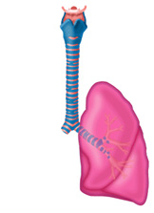
Lobectomy  Also called a pulmonary lobectomy, it is a common surgical procedure that removes one lobe of the lung that contains cancerous cells. Removal of two lobes is called bilobectomy. | 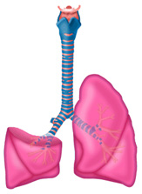
Sleeve Lobectomy  A surgical procedure that removes a cancerous lobe of the lung along with part of the bronchus (air passage) that attaches to it. The remaining lobe(s) is then reconnected to the remaining segment of the bronchus. This procedure preserves part of a lung, and is an alternative to removing the lung as a whole (pneumonectomy). | 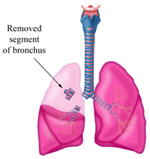
Wedge Resection  A wedge resection is a surgical procedure during which the surgeon removes a small, wedge-shaped portion of the lung containing the cancerous cells along with healthy tissue that surrounds the area. The surgery is performed to remove a small tumor or to diagnose lung cancer. A wedge resection is performed instead of a lobectomy (removing a complete lung lobe) when there is a danger of decreased lung function if too much of the lung is removed. A wedge resection can be performed by minimally-invasive video-assisted thoracoscopic surgery (VATS) or a thoracotomy (open chest surgery). | 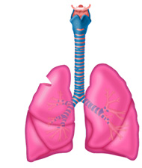
Segment Resection (Segmentectomy)  A segment resection removes a larger portion of the lung lobe than a wedge resection, but does not remove the whole lobe. | 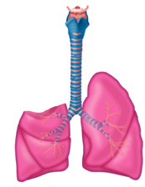
Text and pictures from University of Southern California, Keck School of Medicine

Definitions of body position during surgery

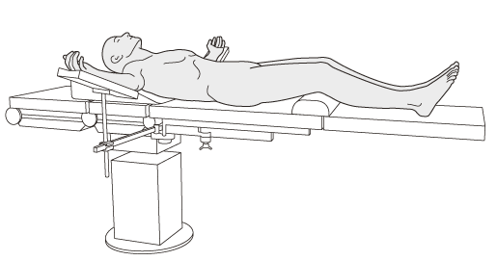
Supine position

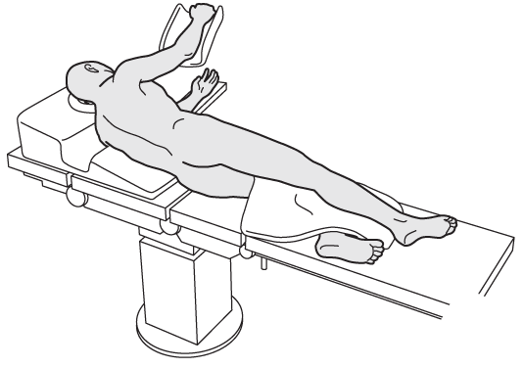
Lateral position

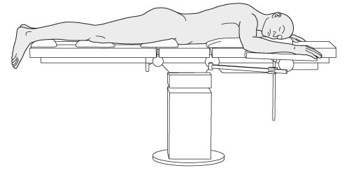
Prone position

Table of body height correlated to ideal body weight

Formula: | Male: 50+0.91*(height-152.4) | Female: 45.5+0.91*(height-152.4)

Ideal body weight(kg)
Height | Gender
cm | male | female
145 | 43,3 | 38,8
146 | 44,2 | 39,7
146 | 44,2 | 39,7
147 | 45,1 | 40,6
147 | 45,1 | 40,6
148 | 46,0 | 41,5
148 | 46,0 | 41,5
149 | 46,9 | 42,4
149 | 46,9 | 42,4
150 | 47,8 | 43,3
150 | 47,8 | 43,3
151 | 48,7 | 44,2
151 | 48,7 | 44,2
152 | 49,6 | 45,1
152 | 49,6 | 45,1
153 | 50,5 | 46,0
153 | 50,5 | 46,0
154 | 51,5 | 47,0
154 | 51,5 | 47,0
155 | 52,4 | 47,9
155 | 52,4 | 47,9
156 | 53,3 | 48,8
156 | 53,3 | 48,8
157 | 54,2 | 49,7
157 | 54,2 | 49,7
158 | 55,1 | 50,6
158 | 55,1 | 50,6
159 | 56,0 | 51,5
159 | 56,0 | 51,5
160 | 56,9 | 52,4
160 | 56,9 | 52,4
161 | 57,8 | 53,3
161 | 57,8 | 53,3
162 | 58,7 | 54,2
162 | 58,7 | 54,2
163 | 59,6 | 55,1
163 | 59,6 | 55,1
164 | 60,6 | 56,1
164 | 60,6 | 56,1
165 | 61,5 | 57,0
165 | 61,5 | 57,0
166 | 62,4 | 57,9
166 | 62,4 | 57,9
167 | 63,3 | 58,8
167 | 63,3 | 58,8
168 | 64,2 | 59,7
168 | 64,2 | 59,7
169 | 65,1 | 60,6
169 | 65,1 | 60,6
170 | 66,0 | 61,5
170 | 66,0 | 61,5
171 | 66,9 | 62,4
171 | 66,9 | 62,4
172 | 67,8 | 63,3
172 | 67,8 | 63,3
173 | 68,7 | 64,2
173 | 68,7 | 64,2
174 | 69,7 | 65,2
174 | 69,7 | 65,2
175 | 70,6 | 66,1
175 | 70,6 | 66,1
176 | 71,5 | 67,0
176 | 71,5 | 67,0
177 | 72,4 | 67,9
177 | 72,4 | 67,9
178 | 73,3 | 68,8
178 | 73,3 | 68,8
179 | 74,2 | 69,7
179 | 74,2 | 69,7
180 | 75,1 | 70,6
180 | 75,1 | 70,6
181 | 76,0 | 71,5
181 | 76,0 | 71,5
182 | 76,9 | 72,4
182 | 76,9 | 72,4
183 | 77,8 | 73,3
183 | 77,8 | 73,3
184 | 78,8 | 74,3
184 | 78,8 | 74,3
185 | 79,7 | 75,2
185 | 79,7 | 75,2
186 | 80,6 | 76,1
186 | 80,6 | 76,1
187 | 81,5 | 77,0
187 | 81,5 | 77,0
188 | 82,4 | 77,9
188 | 82,4 | 77,9
189 | 83,3 | 78,8
189 | 83,3 | 78,8
190 | 84,2 | 79,7
190 | 84,2 | 79,7

Scheme of selective oxygen insufflation during one lung ventilation

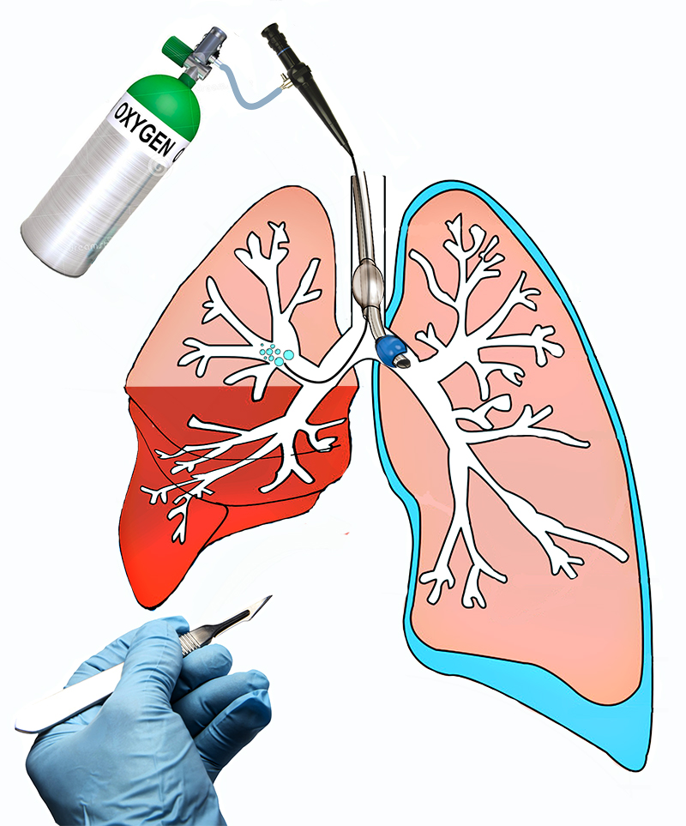

Selective oxygen insufflation to the right upper lobe via fiberscope during one lung ventilation. The remaining part of the right lung is collapsed. The left lung is ventilated through the double lumen tube.

Measurement of abdominal pressure
A closed, needle-free system for measurement of intravesicular pressure. Normal saline (1,000 mL), a 60-mL Luer lock syringe, and a segment of pressure tubing are attached to a disposable pressure transducer connected to two stopcocks. An 18-gauge angiocatheter is inserted into the culture aspiration port of the urinary drainage tubing and the needle removed leaving the plastic infusion catheter in place. The infusion catheter is connected to the pressure tubing and the system flushed with normal saline. The infusion catheter may be taped to the urinary drainage tubing for added security.
To measure intraabdominal pressure, the urinary drainage tubing is clamped immediately distal to the catheter. The stopcocks are turned “off ” to the patient and to the pressure transducer. Normal saline is aspirated from the IV bag using the 60-mL syringe. The first stopcock is turned “on” to the patient and the normal saline instilled into the bladder through the urinary catheter. The process is repeated until a total of 100 mL of normal saline has been instilled into the bladder. The stopcocks are then turned “off ” to the syringe and IV tubing. The clamp on the urinary drainage tubing is momentarily released to ensure that all air is flushed from the urinary catheter. The patient’s intraabdominal pressure is then measured at end-expiration. The clamp is removed, the bladder allowed to drain, and the 100 mL of fluid subtracted from the patient’s urinary output for that hour.
(from: Intraabdominal Pressure: A Revised Method for Measurement; Michael L Cheatham, MD, and Karen Safcsak, RN; 1998 by the American College of Surgeons)

Assessment of metabolic equivalents
Estimated energy requirements for various activities.
One MET equals the basal metabolic rate. Exercise testing provides an objective assessment of functional capacity. Without testing, functional capacity can be estimated from the ability to perform the activities of daily living. One MET represents metabolic demand at rest; climbing two flights of stairs demands 4 METs, and strenuous sports, such as swimming, > 10 METS. The inability to climb two flights of stairs or run a short distance (<4 METs) indicates poor functional capacity and is associated with an increased incidence of post-operative cardiac events. Abbreviations: km per h = kilometres per hour; MET = metabolic equivalent.
Based on Hlatky MA, et al . A brief self-administered questionnaire to determine functional capacity (the Duke Activity Status Index). Am J Cardiol 1989;64:651–654. and Fletcher GF et al. Exercise standards for testing and training: A statement for healthcare professionals from the American Heart Association. Circulation 2001;104:1694–1740)
From: 2014 ESC/ESA Guidelines on non-cardiac surgery: cardiovascular assessment and management. European Heart Journal (2014) 35, 2383–2431

